**Question 1**

1. Use “ FIFA 22 complete player dataset from Kaggle, players_22.csv” from previous lab.

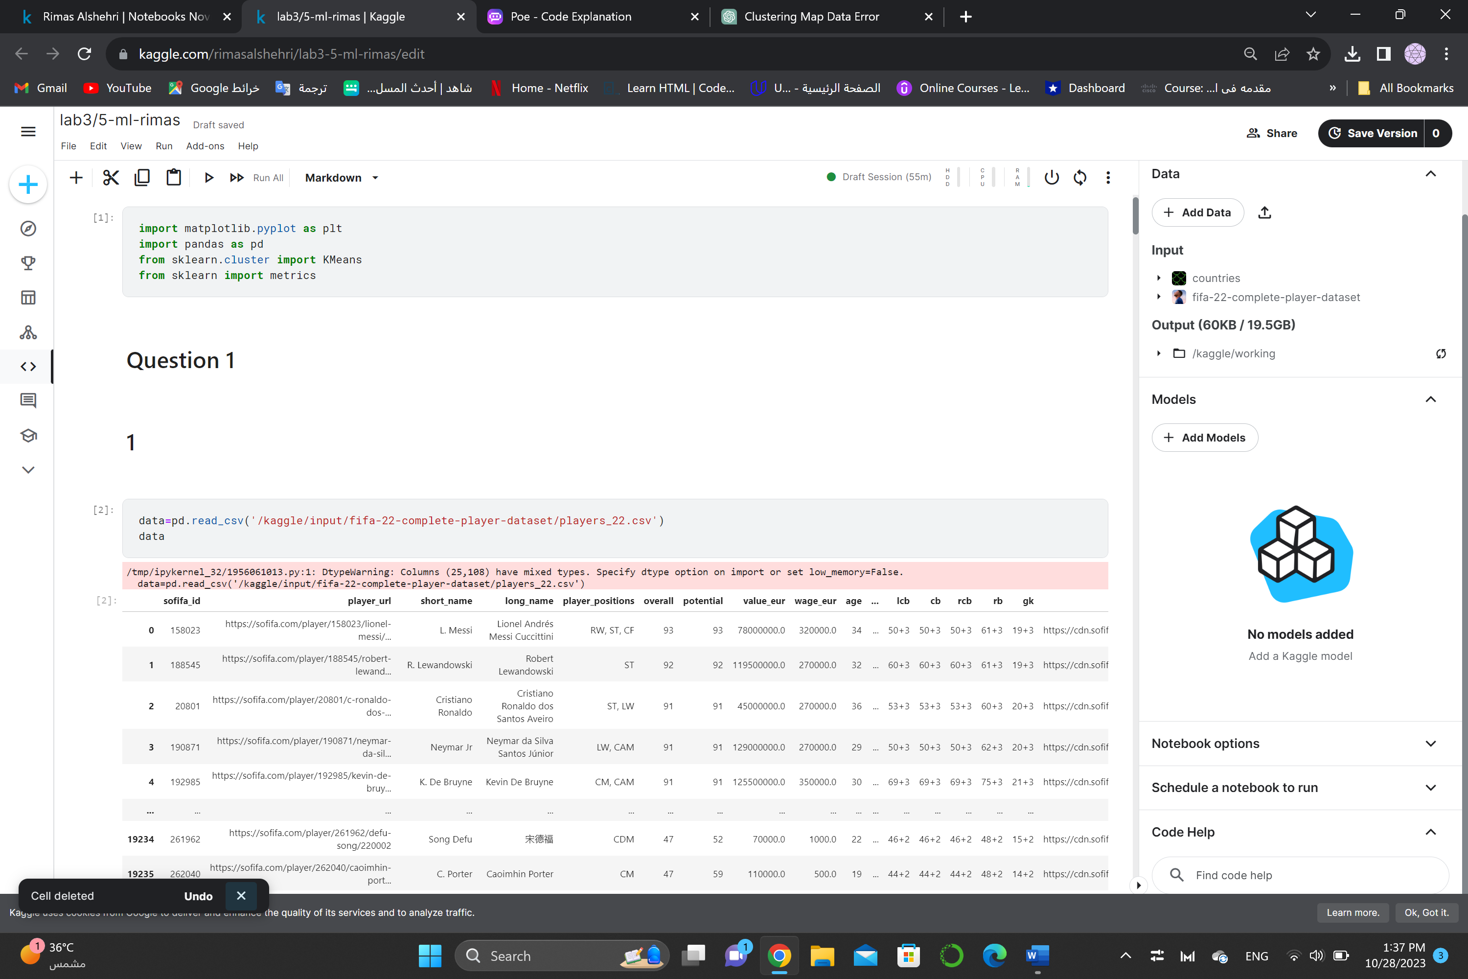

1. Use the same columns and the standardization method specified in lab2.

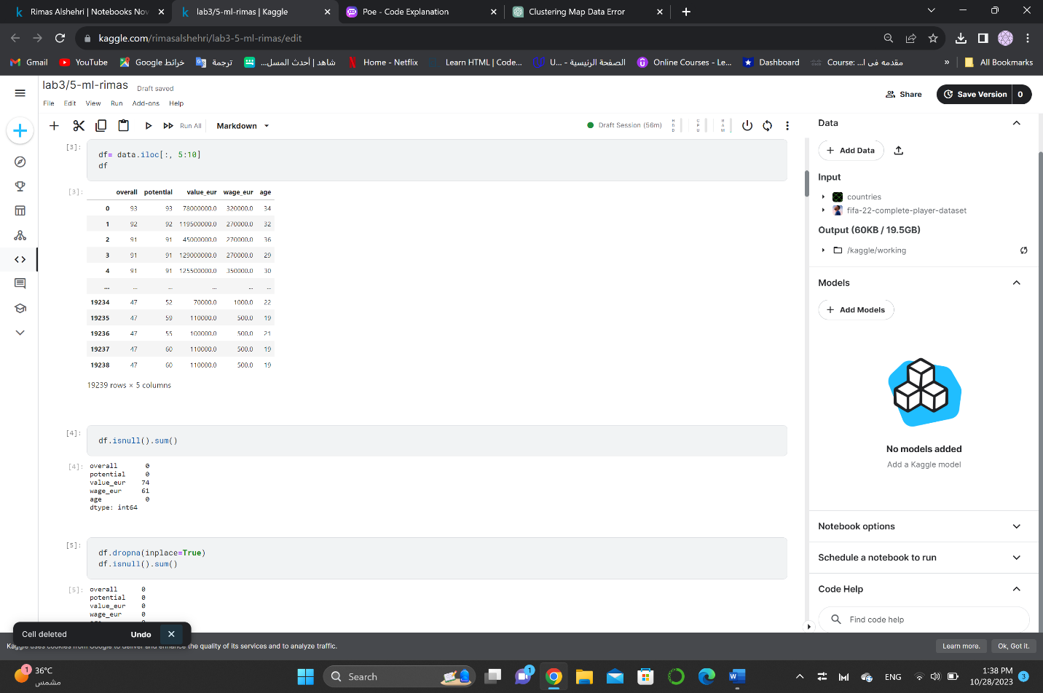

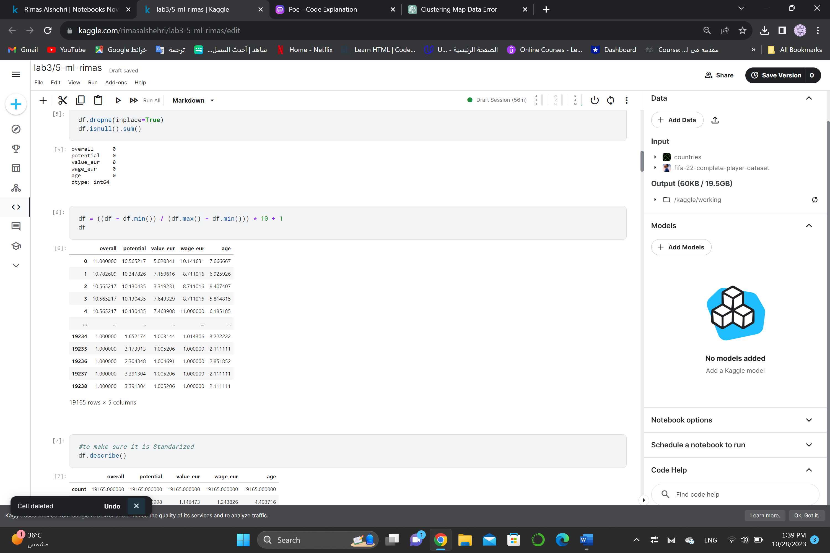 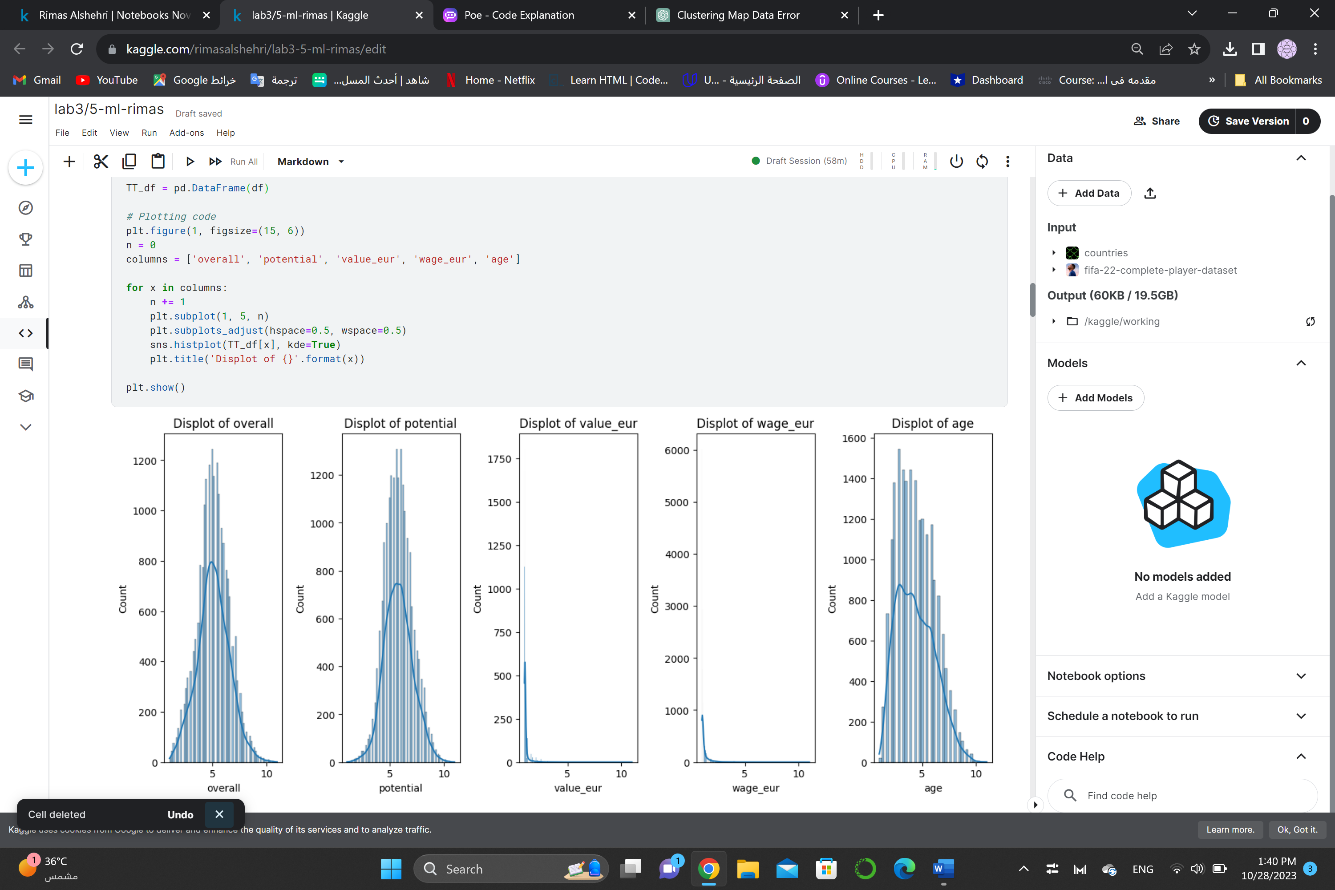

1. Apply hierarchical method using ward method in in scipy package.

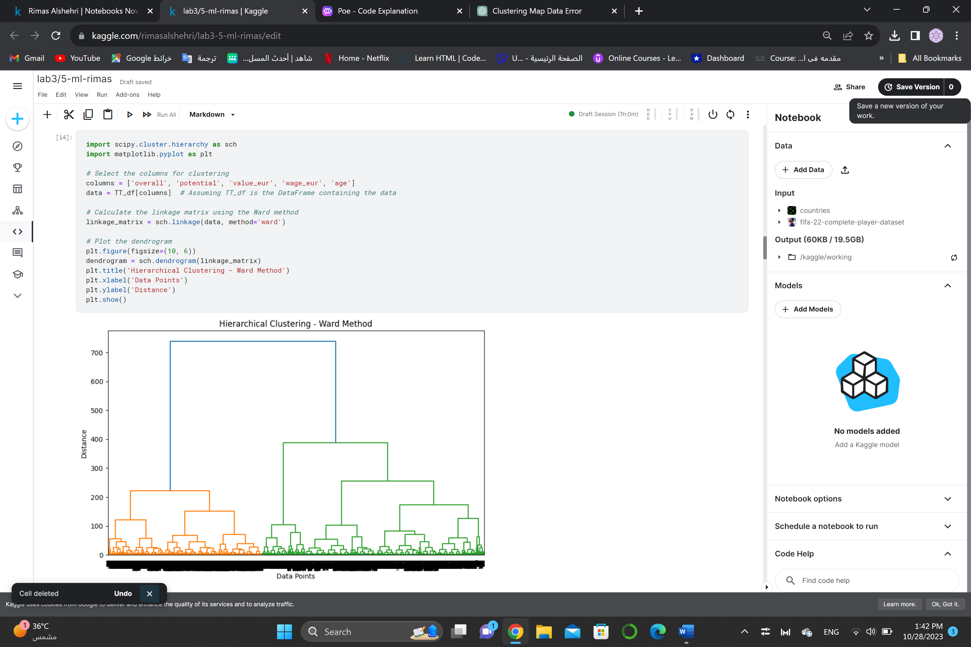

1. Use dendrogram to find the best value of the number of clusters that should be for this dataset (in your opinion where is the best cute in the dendrogram).

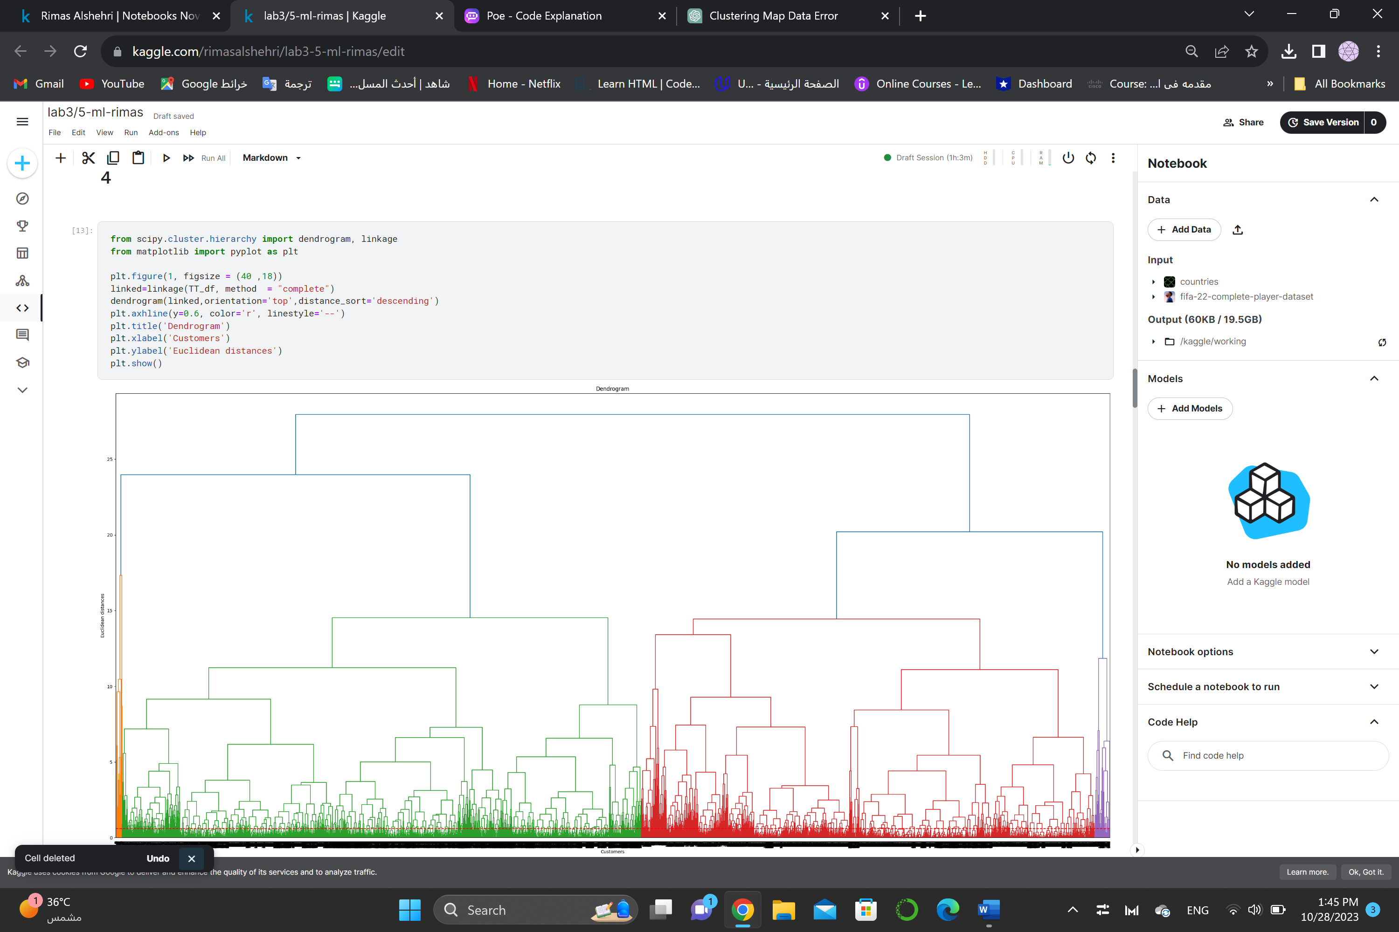

Cluster cut in red

1. Compare the number of clusters you chose using dendrogram to elbow method you used in lab2, is there a difference? And which methods you would prefer to find the number of clusters and why?

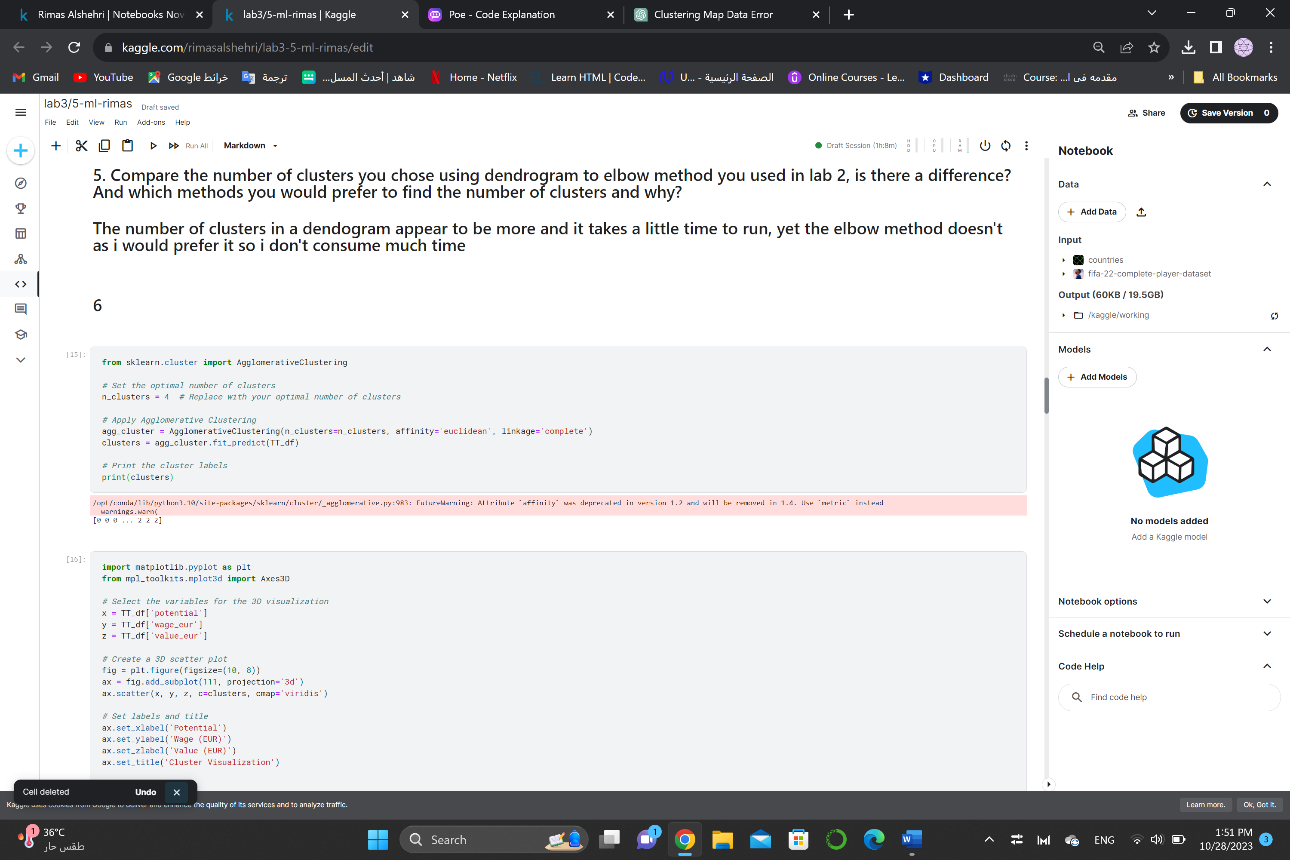

1. Apply Agglomerative Clustering in sklearn with the best value of the number of clusters you found in step 4

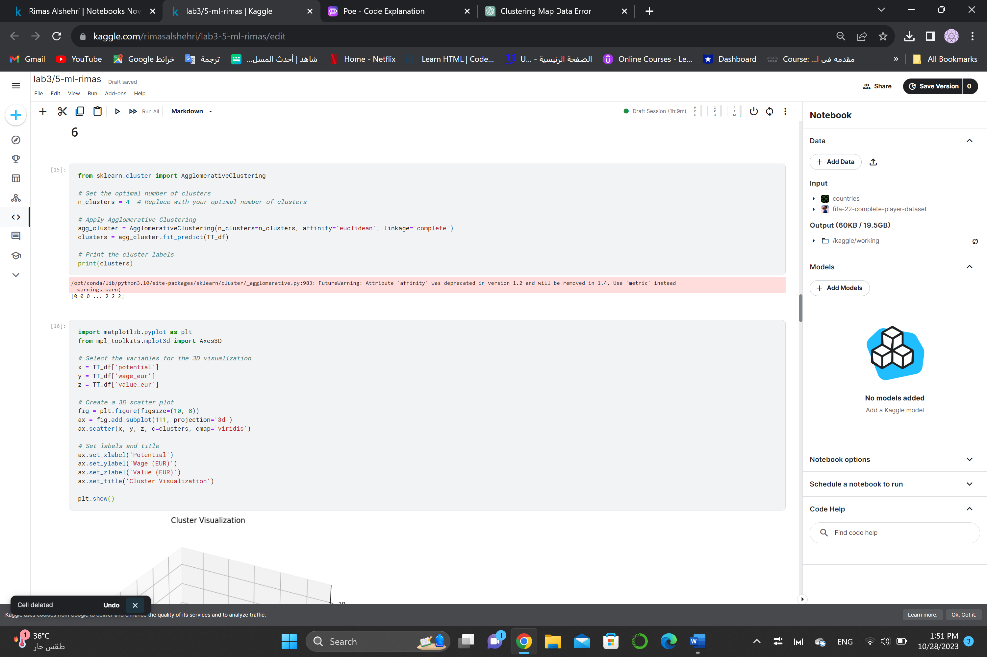

1. Visualize the resulting cluster using 3D visualization (you can reuse the code in the notebook given in the lab), choose "potential", "wage_eur", "value_eur" as x, y, z axis.

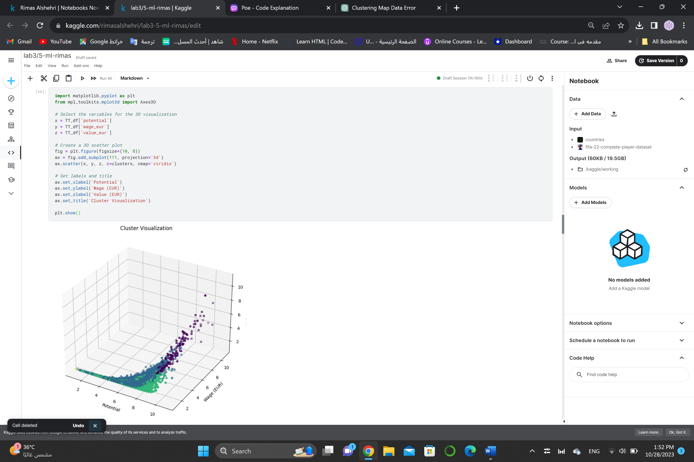

1. Read about ward method and explain how this method calculate the distance between clusters.

When merging clusters, Ward's approach is a hierarchical clustering algorithm designed to reduce the within-cluster variance. The increase in the total within-cluster sum of squares (WCSS) following merging is used to compute the distance between clusters.

The following are the steps that make up Ward's method:

To begin, treat each data point as a separate cluster.

Determine the Euclidean distance between every two cluster pairs.

Combine the two groups that yield the least increase in the overall WCSS. The amount that the total variance within the clusters increases upon merging is indicated by this increase in WCSS.

Determine the new cluster's distances from the other clusters once again.

Steps 3 and 4 should be repeated until all data points are combined into a single cluster or until desired number of clusters reached.

Question 2

1. Use the dataset “countries_continents.csv” from previous lab.

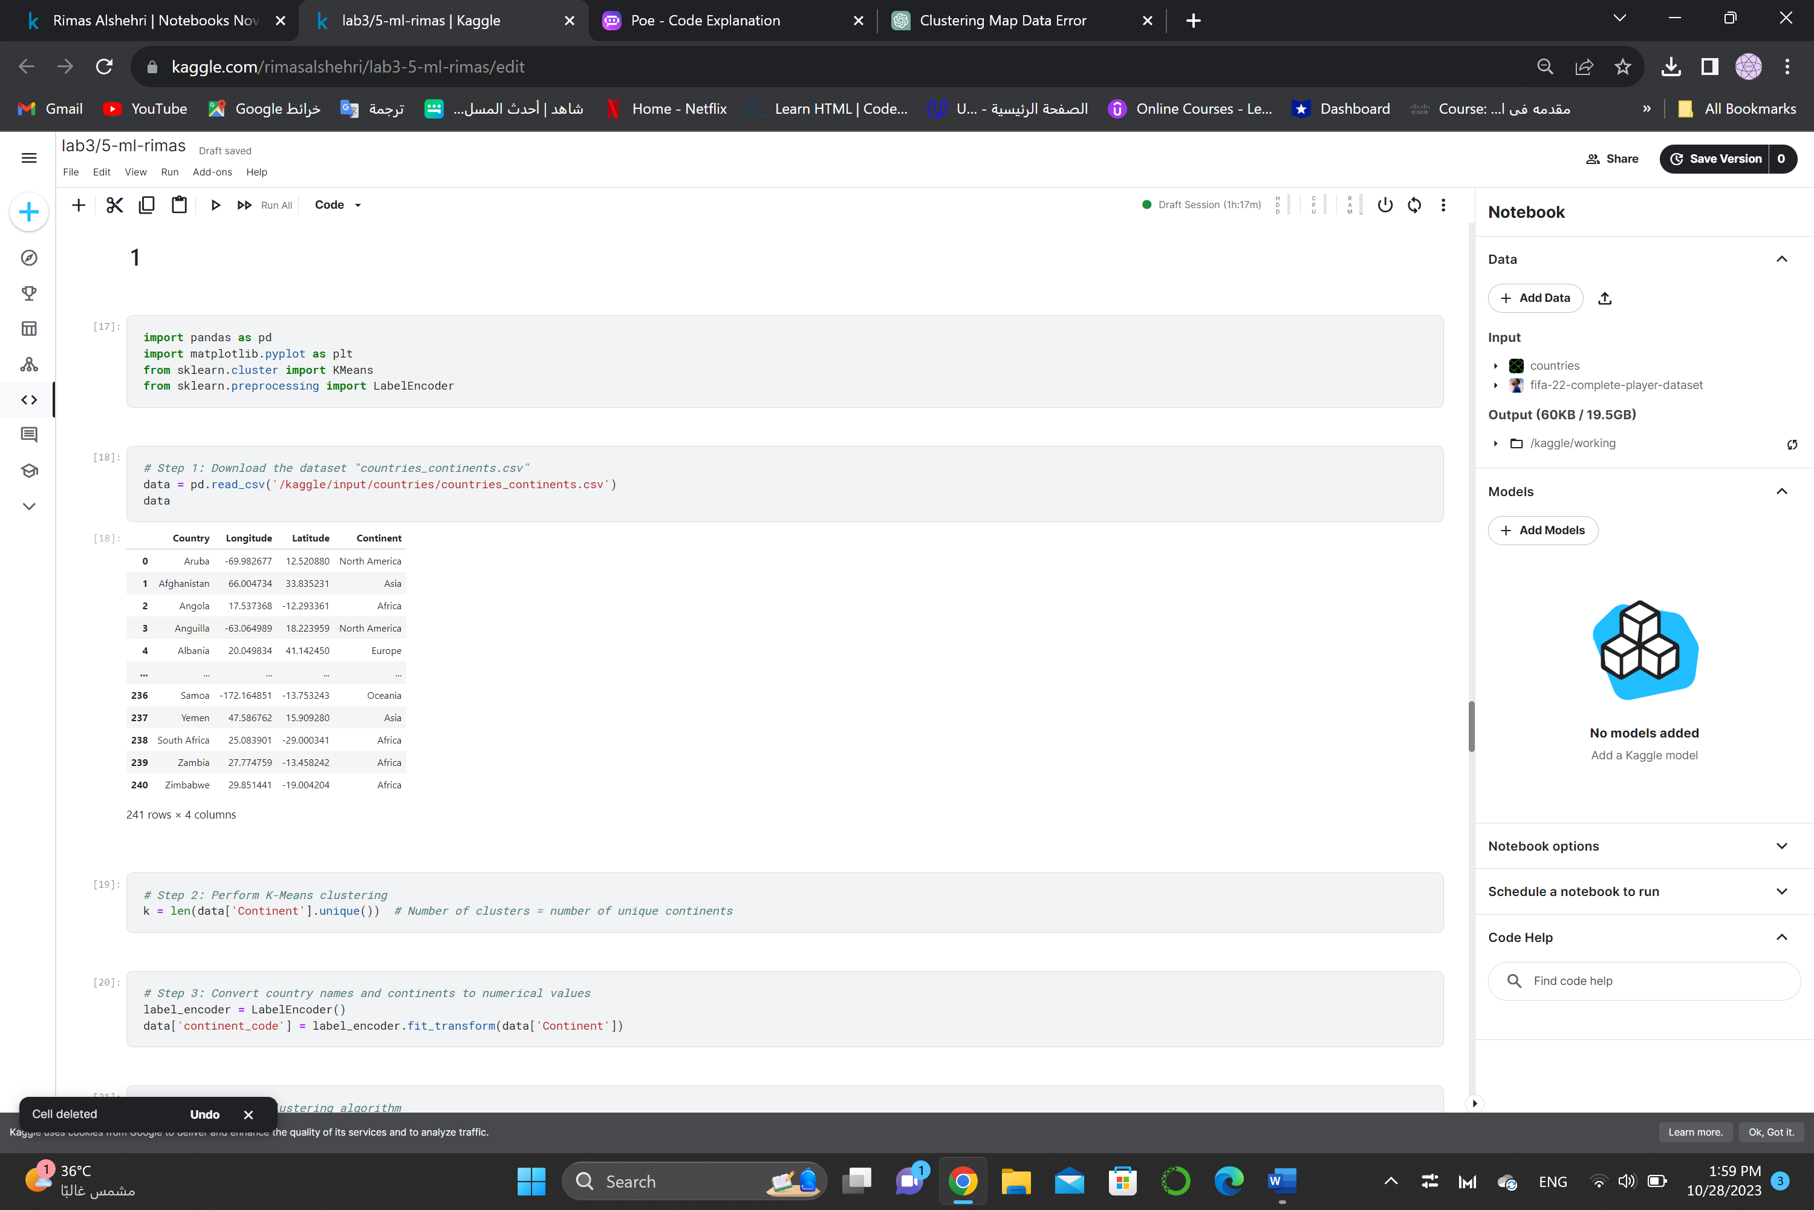

1. Apply hierarchical method using 4 cluster metrics (single, complete, average, ward) in scipy package

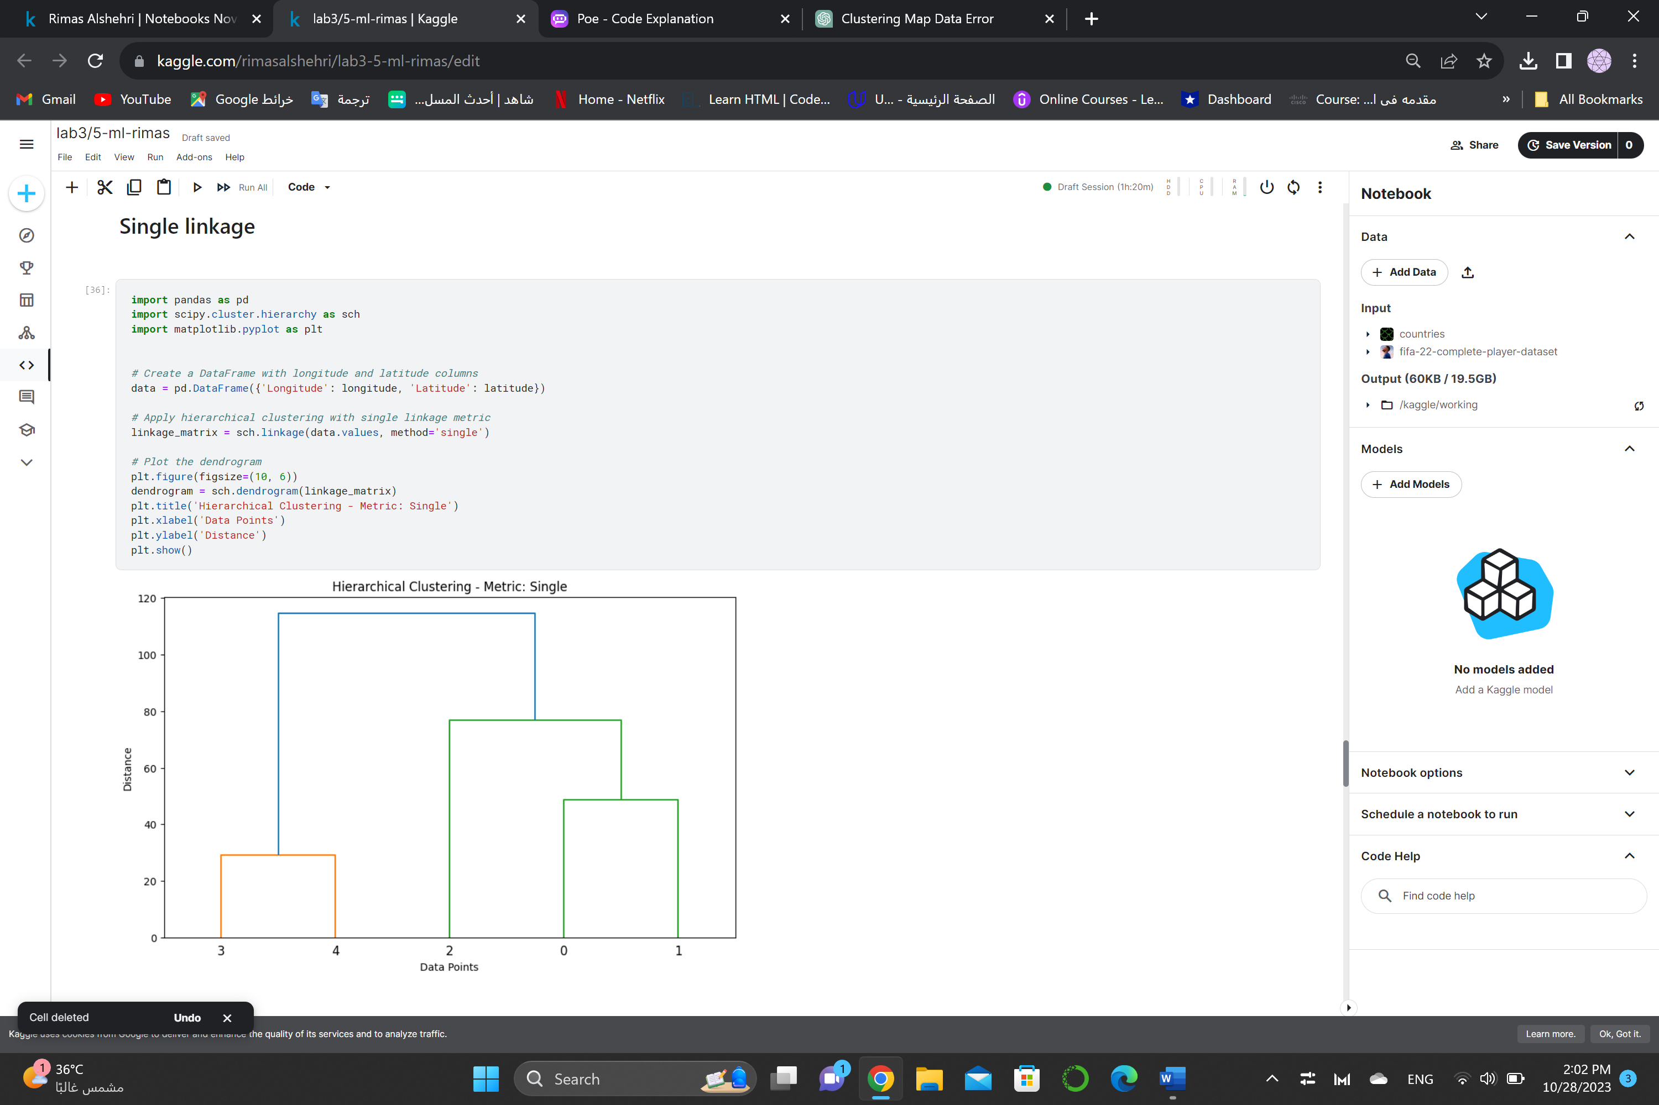 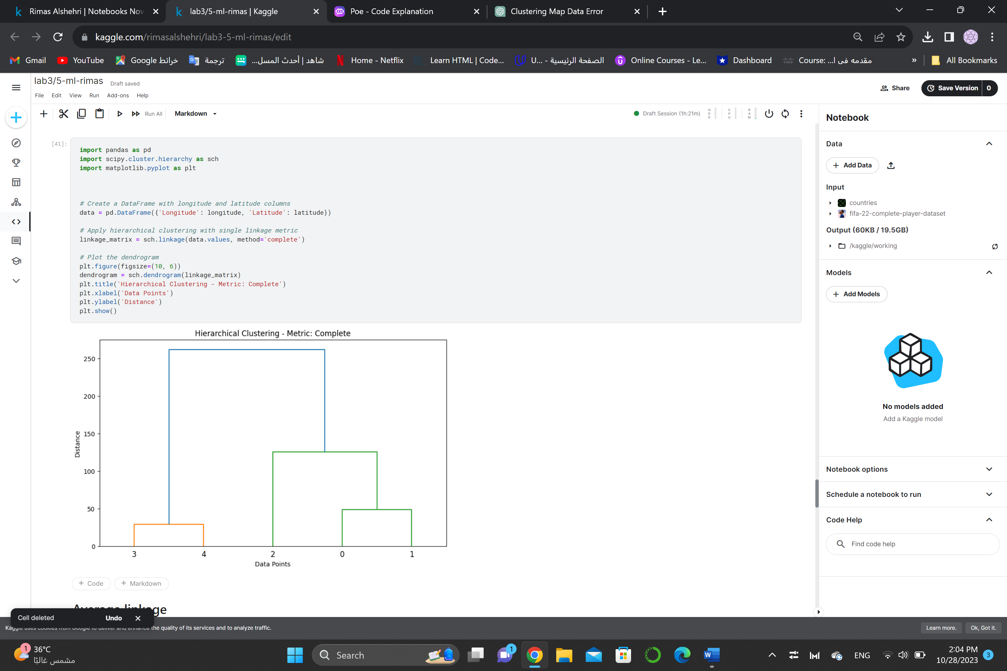

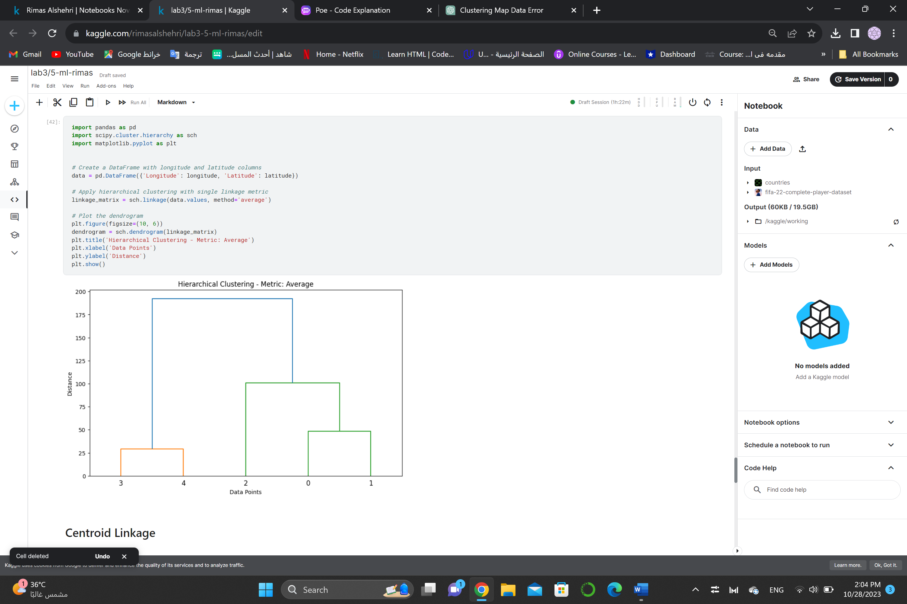 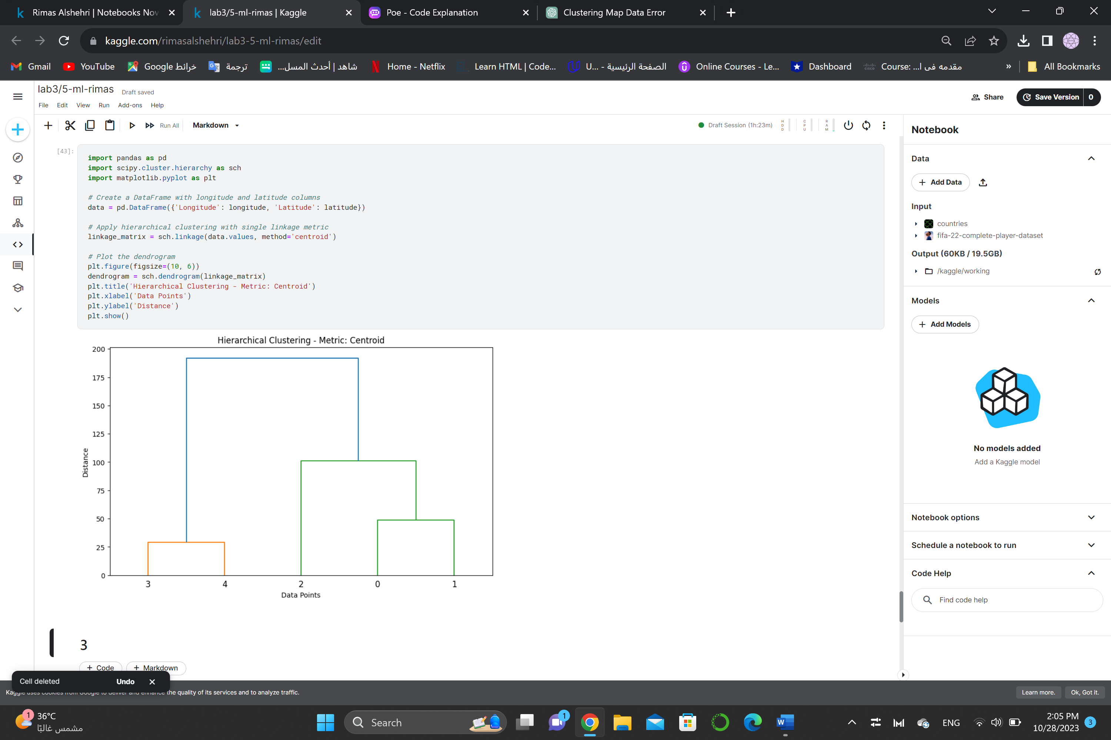

1. Show the dendrogram for each metric and draw a line that show the best cute in your opinion (the cut that gives the number of clusters).

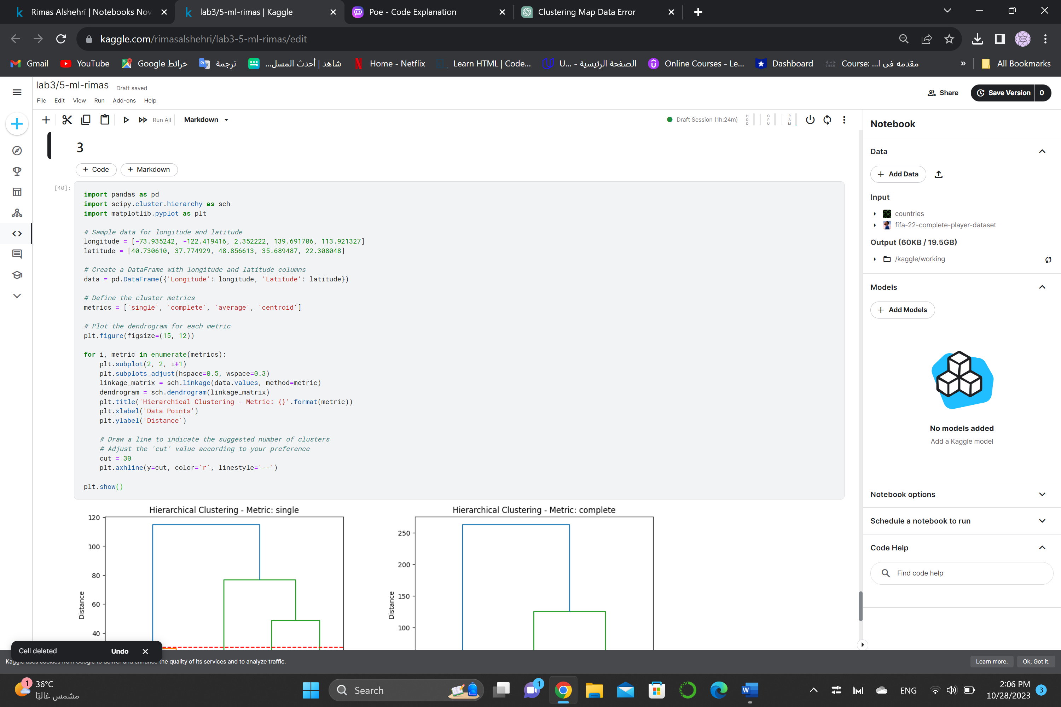 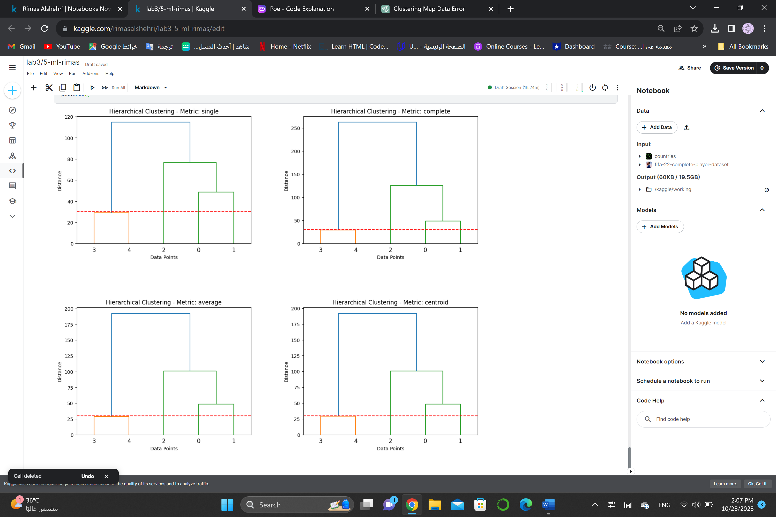

1. In your opinion, which clustering metrics is showing reasonable results and why.

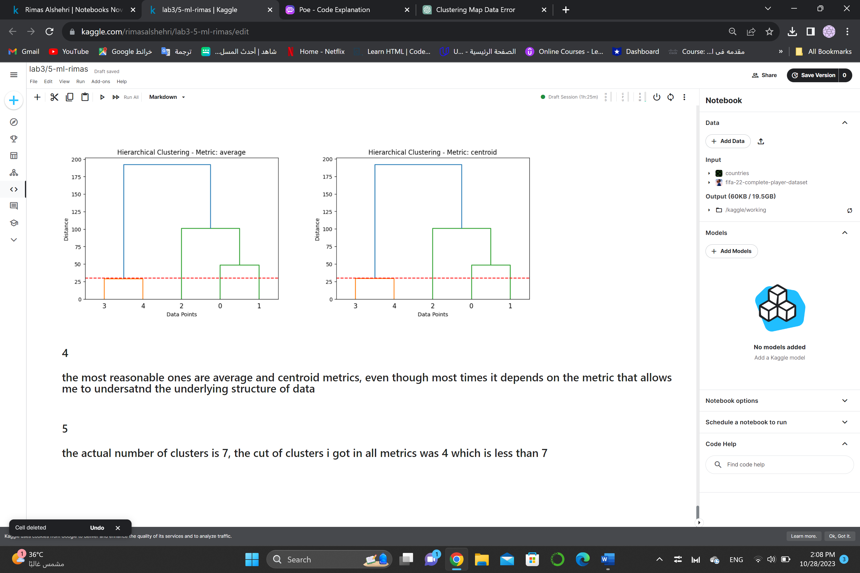

1. Compare your choice of the number of clusters in all the 4 cluster metrics (in step 3) with the actual number of clusters in the dataset, in which metrics you choose the closest number of clusters to the actual one.

